Comparative Modifier

🔹 What Is Comparative Modifier?
# Source: AI Source: Provided by: [Data Path: Persons Table -> ID Column: 1, Name_En Column: Motasem Essam] -> From: [Chatgpt (GPT‑5 Mini)] on [8/7/2025]
A comparative modifier is a word or phrase—often an adjective or adverb in comparative form—that compares two people, things, actions, or states in terms of quality, quantity, or degree.

🔸 Function:
# Source: AI Source: Provided by: [Data Path: Persons Table -> ID Column: 1, Name_En Column: Motasem Essam] -> From: [Chatgpt (GPT‑5 Mini)] on [8/7/2025]
It answers questions like:
"More than what?", "Which is better/faster/smarter?"

🔸 Common Forms of Comparative Modifiers:
# Source: AI Source: Provided by: [Data Path: Persons Table -> ID Column: 1, Name_En Column: Motasem Essam] -> From: [Chatgpt (GPT‑5 Mini)] on [8/7/2025]
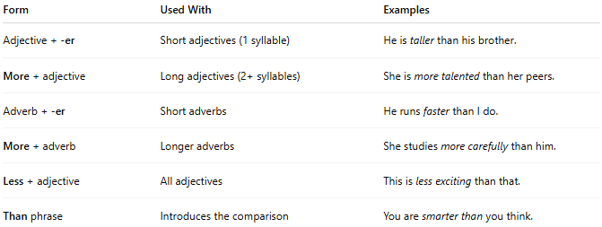
Form | Used With | Examples
Adjective + -er | Short adjectives (1 syllable) | He is taller than his brother.
More + adjective | Long adjectives (2+ syllables) | She is more talented than her peers.
Adverb + -er | Short adverbs | He runs faster than I do.
More + adverb | Longer adverbs | She studies more carefully than him.
Less + adjective | All adjectives | This is less exciting than that.
Than phrase | Introduces the comparison | You are smarter than you think.

🔸 Examples in Sentences:
# Source: AI Source: Provided by: [Data Path: Persons Table -> ID Column: 1, Name_En Column: Motasem Essam] -> From: [Chatgpt (GPT‑5 Mini)] on [8/7/2025]
- This book is longer than the last one.
- He arrived more quickly than expected.
- The cake is less sweet than usual.
- She is funnier than her sister.
- My car is more expensive than his.

🔸 Placement:
# Source: AI Source: Provided by: [Data Path: Persons Table -> ID Column: 1, Name_En Column: Motasem Essam] -> From: [Chatgpt (GPT‑5 Mini)] on [8/7/2025]
- Before the word being modified.
- Often followed by "than" for explicit comparison.

🔸 Notes:
# Source: AI Source: Provided by: [Data Path: Persons Table -> ID Column: 1, Name_En Column: Motasem Essam] -> From: [Chatgpt (GPT‑5 Mini)] on [8/7/2025]
- Avoid double comparatives (e.g., "more better" ❌).
- Some adjectives and adverbs are irregular:
  - good → better
  - well → better
  - bad → worse
  - far → farther/further

